Winston-Salem Street School

2020 / 2021 Operational Plans

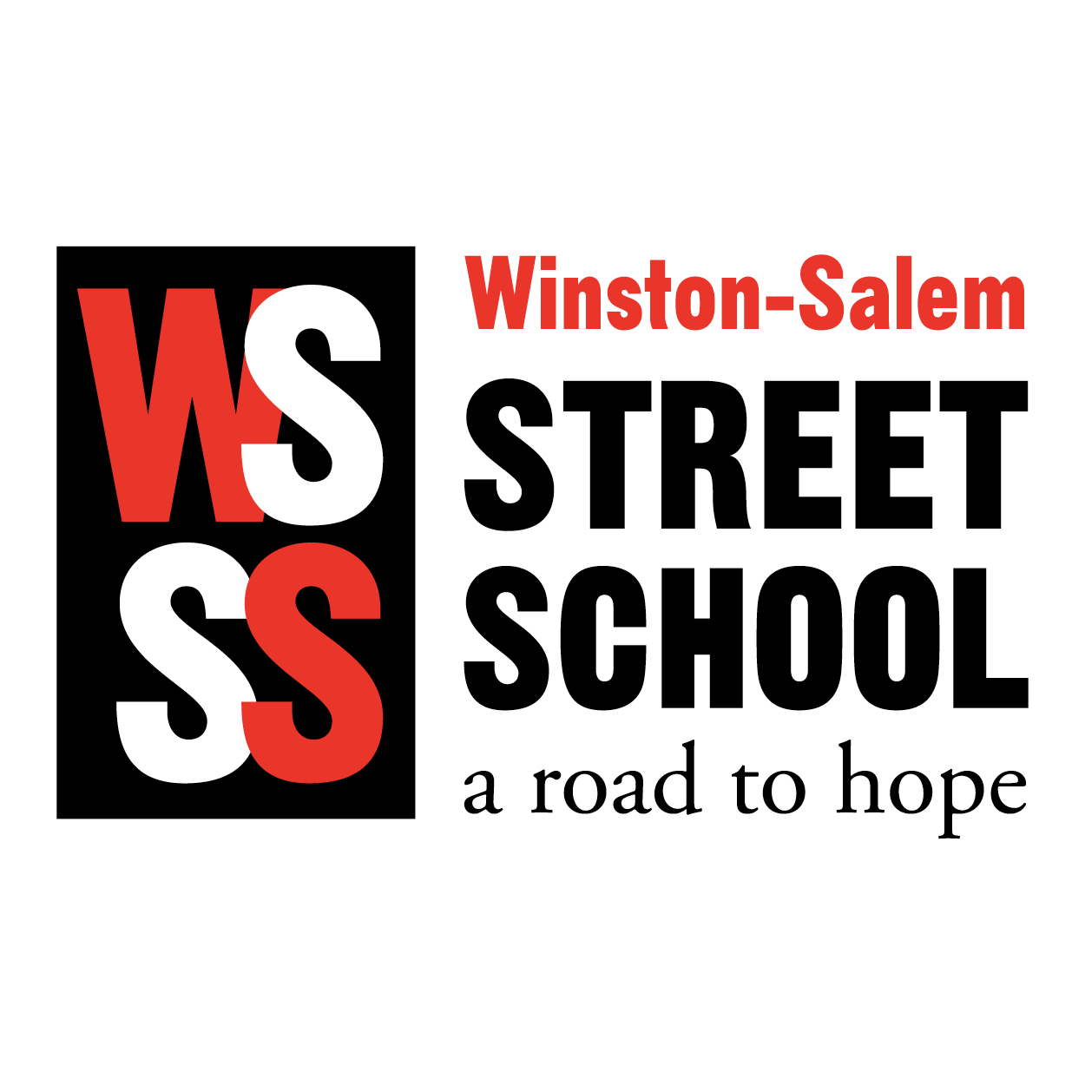

In response to the impact of the COVID-19 pandemic, the Winston-Salem Street School is implementing new safety measures for the 2020/2021 school year. Please know we are doing everything within our power to make sure our students and staff have a healthy learning environment and workplace. We will reevaluate safety measures throughout the year and make necessary changes as needed.

- First day of school - Monday, August 31, 2020 (student / family orientation sessions - date TBA)
- A/B rotating schedule to limit number of students (combination of in-school and distance learning)
- Masks and daily temperature checks required for staff and students upon entering the school
- Social distancing practiced in classes and throughout facility
- Hand sanitizing and disinfecting of desks and chairs before and after each class
- Hand sanitizing stations located throughout facility
- Weekly sanitizing and disinfecting services
- Option to transition to 100% distance learning if needed

www.wsstreetschool.org
(336) 721-1110

